CSCI.4923 Capstone in Interprofessional Informatics

Civil Scientist Soil Submission Database

Morelia A. Sosa

Texas Woman's University

Denton, Texas

# Author Note

Morelia Sosa, Texas Woman’s University, Mathematics & Computer Science

# Table of Contents

**Problem Identification** 3

**Literature Review**3

Search Process 5

**Formulation of Innovative Approach for an Informatics Problem**5

Proposed Approach 5

**Outcomes and Associated Evaluation Criteria**11

Other Experiences Associated with Capstone Project11

References 12

# 

# 

# Civil Scientist Soil Submission Database

# Problem Identification

The problem identification is the need for software to assist Dr. Salazar (customer) in the process of managing the soil submission of civil scientists. Rather than manually storing and remembering soil submissions and analysis, Dr. Salazar and his team could swiftly use the web application to manage the data.

**Literature Review**

Databases centered in scientific research allow for the incorporation of different data sets and allow data to be analyzed in new ways, often across different subjects, making new types of scientific inquiry possible. Four hundred million tons of plastic products are made annually, this amount will double by the year 2050. (Lim, X 2021) Plastics are versatile, durable, and cost-effective materials that are used in our daily lives. However, due to the poor natural deterioration, millions of tons of plastic waste are dumped into the environment. The study Dr. Salazar and his team will be focusing on is the impact of plastic pollution on our environment, specifically microplastics. Dr. Salazar’s project focused on discovering microplastics in soil from Denton, Texas. This project is important because we want to learn more about the impact of plastic pollution on our environment. The definition of soil regarding Dr. Salazar's project is the diverse habitat of different animals, bacteria and plants that are found within soil, especially those that help plant growth, water storage, nutrient cycling, and decomposition. Microplastics are heterogeneously mixed plastics that are less than 5 mm in diameter, they include plastic fibers, granules, and fragments. Microplastic contamination is a growing hazard to ecosystems, agricultural production, groundwater, plant growth, human and animal health.

Although there is an increased concern for microplastic contamination, a majority of the research is focused on aquatic ecosystems, the research conducted by Dr. Salazar and his team will focus primarily on terrestrial ecosystems specifically in Denton County. The data being collected will show the seriousness of microplastics in soil emphasizing the various ways they may enter the soil and their migration within soil. This will be illustrated in the submission form and the database will assist in showing the effects microplastics have on the nutrients of the soil.

This growing concern has sparked a new field of research, which has led to the development of new databases. Although databases vary in scope, all databases have the same fundamental developmental steps, such as requirements of collection, modeling, implementation, development, and use. The scope influences the size, complexity, cost in time and resources required for each of these steps. The data being collected will be considered analytical information focusing on quickly analyzing massive amounts of data to show patterns of microplastic pollution in Denton County. Yet this capstone will be a modest version of the large-scale database that will be needed for this research. This prototype can be developed later into a more widely accessible system that will help with a better understanding and practice of the different effects microplastics have on our environment.

# Formulation of Innovative Approach for an Informatics Problem

## Proposed Approach

The proposed approach of this capstone project is to develop a database to help store and analyze submitted data for Dr. Salazar and his team to review the effects microplastics have on Denton County soil. This process will be utilized by average people who either want to participate in a study or who want to have a better understanding of the effect microplastic pollution has on Denton County soil.

The civil scientist will conduct the soil extraction following the steps explained at the top of the page or from the instructional video. Once conducted, the civil scientist will be asked a series of questions to help understand the sample's history. Once submitted, the data is stored in MySQL and is only accessible through registering and or logging in. This will give the user full access to the data submitted and the database data visualizations. This sample will then be updated with the analytic analysis conducted by Dr. Salazar's team. ​​The specific components of this approach in order of sequence are:

**Front-end Development**

The first step in building a microplastic database was to formulate an easily comprehensible model of the submission form (Figure 1). This form required extensive details to ensure the sample would be as accurate as possible. I began this process by creating a sample submission form on google form, to understand a basic understanding of the questions that need to be asked in the submission form. This developed into a single-page web application using PHP, HTTP, CSS, and JavaScript.

The submission page is displayed by default as the home page. It allows the user to read how to collect a soil sample. The order of the form is created in a way for the civil scientist to follow the instructions as well as possible. The civil scientist must submit their first and last name, email, ‘location sample was collected’, ‘sample obstruction’ and ‘sample history’. To allow the civil scientist some anonymity, their first name and email are only accessible in MySQL if needed later. The submission is encrypted to keep civil scientist information safe from a SQL injection attack. The user is asked to submit their coordinates and zip code, yet both can be waived for anonymity. The user will then submit with the green ‘submit’ button at the bottom of the page, this will then refresh the form to allow the user to submit other samples.

To access the database Dr. Salazar and his team must either sign up or login to access the previous soil submissions of a civil scientist (Figure 2 & 3). The registration page will require a username, email and password with password confirmation. Once submitted the data is stored in MySQL and the password is encrypted for cyber-security. The user can be deleted/ edited in MySQL. The user will immediately be logged in once submitted and directed to the Microplastic Analysis Database. The login page will request the user to enter their username and password, once entered the user will immediately be directed to the database. Both the registration and login page have links to be redirected back to the submission form or sign up/login page. The soil submission form also has a link located at the top of the page to sign in.

The database page displays the submissions that are given from the civil scientist and includes an ‘Update’ button or ‘Delete’ button (figure 4). The page includes a search bar, ‘Dashboard’ button, ‘Soil Submission Form’ button and ‘Logout' button. The database is listed by ‘id’ which is assigned to each civil scientist submission. Once a new submission is entered the form will include a new unique identification number, last name, coordinates, zip code, property type, obstruction, and history. The columns color, shape, size, pH level, percent mineral content, nitrogen, phosphorus, and potassium will contain no values since they must be updated by Dr. Salazar and his team once the analysis is completed. To update a sample the user will select the ‘Update’ button. This will pull the selected sample base on the unique id (figure 5). The update form required fields are coordinates, zip code, property type, sample obstruction, sample history, color, and shape. I have chosen to allow the other columns to be empty in the instance of a zero. The update form also allows for the column size, pH level, percent mineral content, nitrogen, phosphorus, and potassium to be decimal points to the hundredths place. The update form is submittable if the user presses the ‘Enter’ button on their keyboard or they click the ‘Submit’ button at the bottom of the page. The user can cancel the update with the ‘Cancel’ button at the bottom of the page which will direct the user back to the homepage of the database, where no changes will be submitted. The search tool will pull any sample that matches the data entered. An example is if the user were to search ‘75’, the sample that includes ‘75’ would be displayed, with the option to update or delete. The dashboard page includes three static data visualizations that update with each submission. (Figure 5) The page includes a search bar, ‘Dashboard’ button, ‘Soil Submission Form’ button and ‘Logout' button.



Figure 1 Soil Submission Form

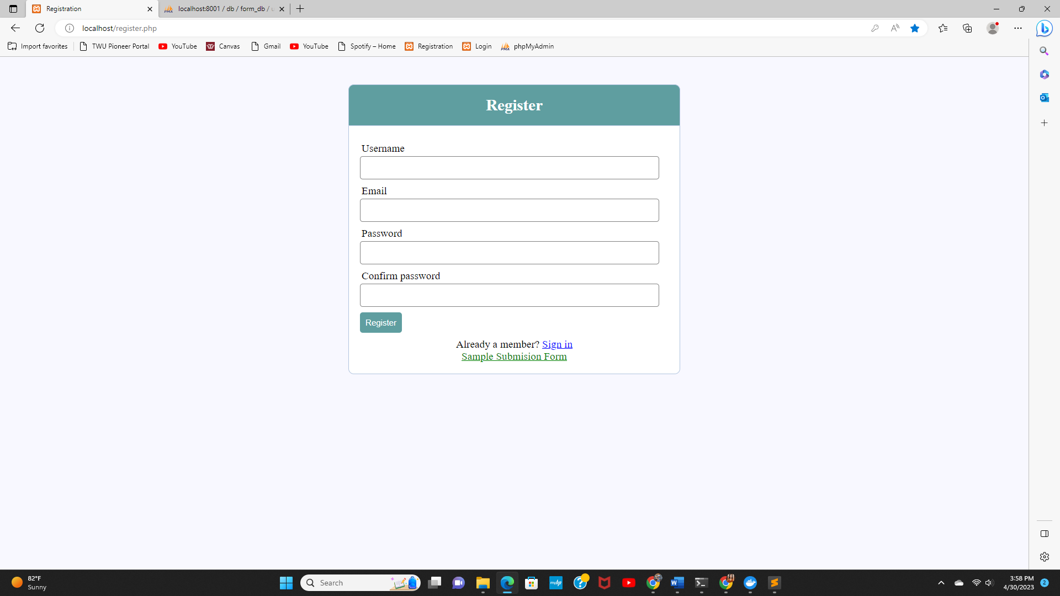

Figure 2 Registration Page

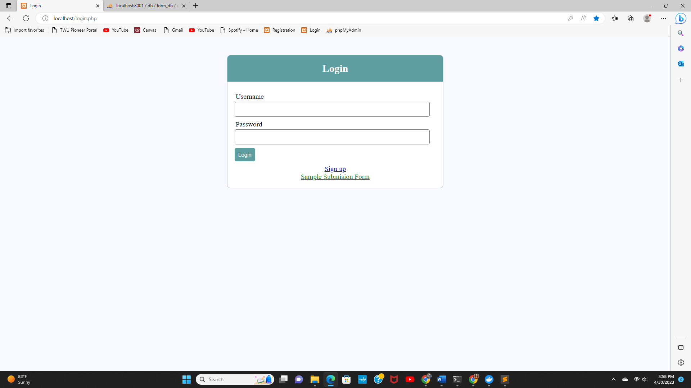

Figure 3 Login Page

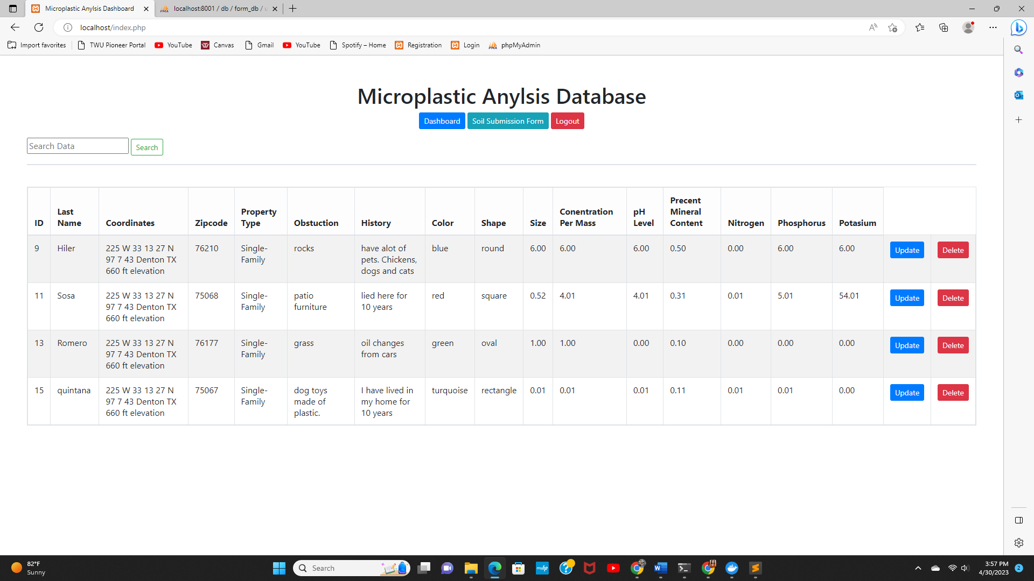

Figure 4 Microplastic Analysis Database

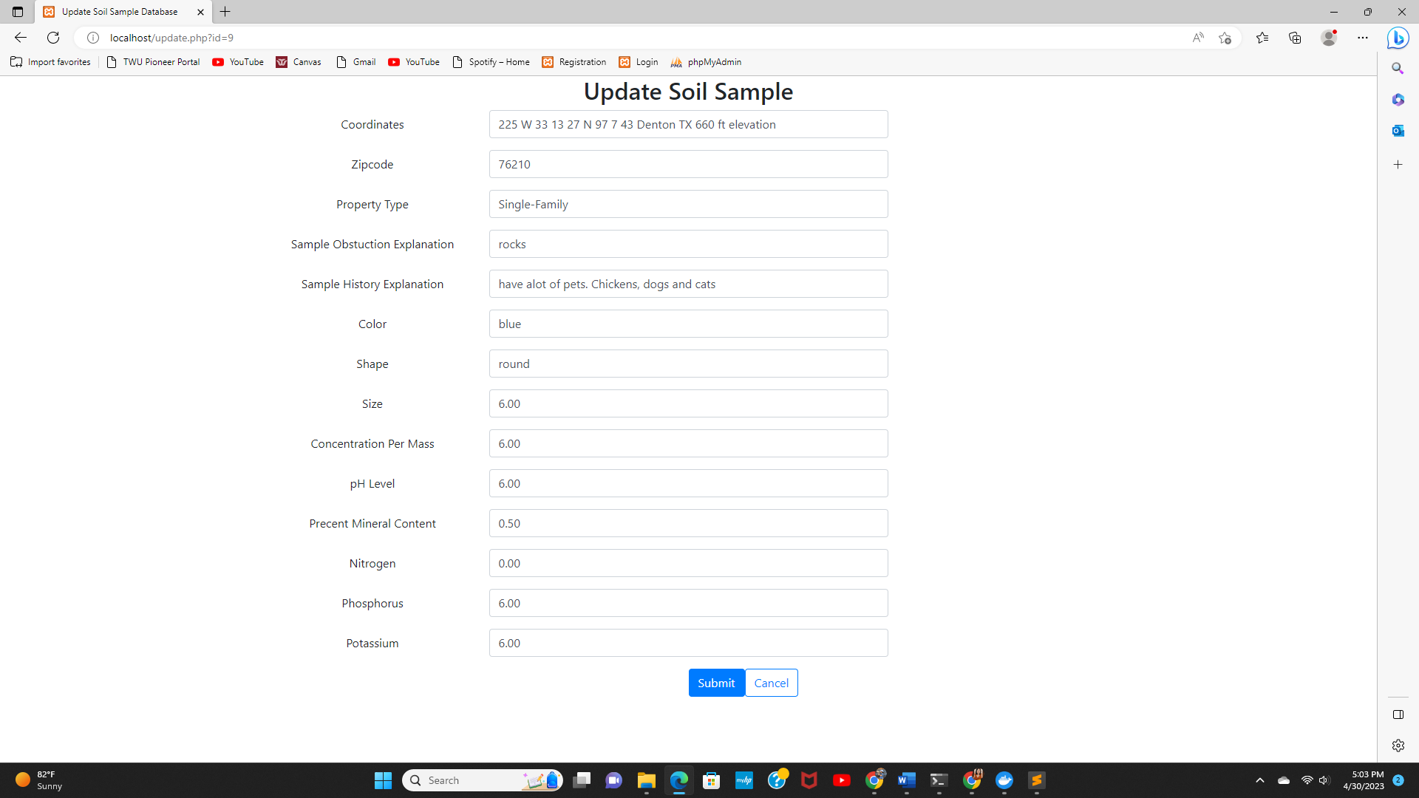

Figure 5 Update Page

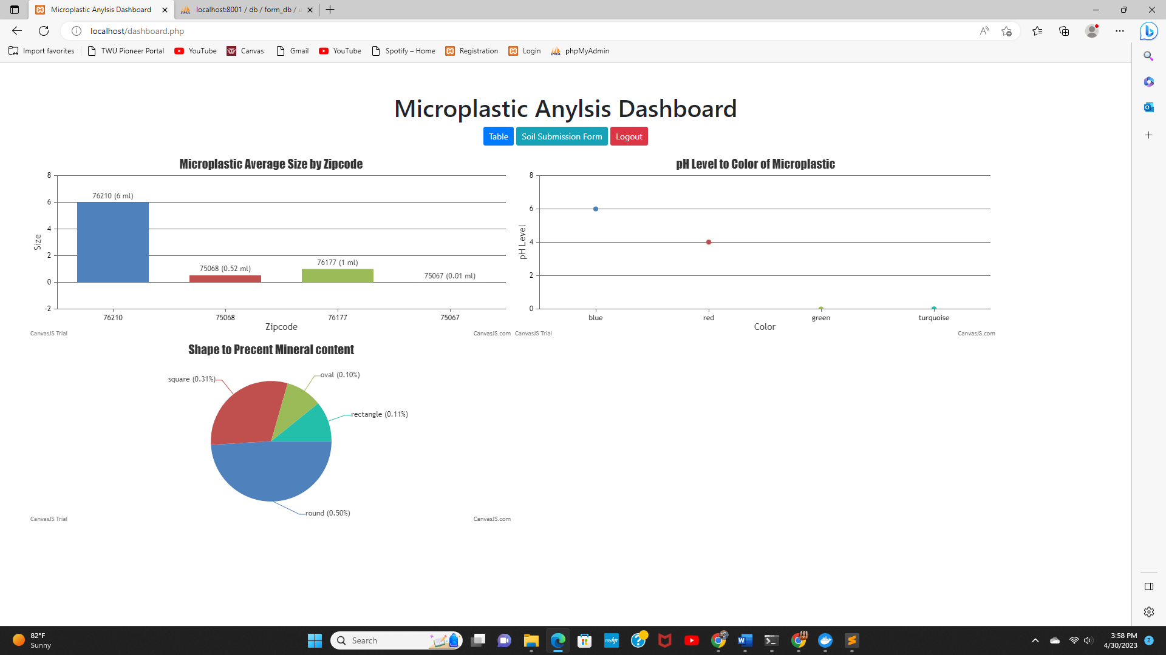

Figure 6 Microplastic Dashboard

**Web Framework**

Initially, Vagrant was the web framework considered for this project, because of its simplicity and support. I decided against this due to the need to have a virtual box due to the issues with using PHP. I then chose Docker for its simplicity. Docker containers are isolated from one another and bundle their own software and configuration files. The containers can then communicate with each other through well-defined channels, which requires fewer resources than Vagrant. This was all attractive due to the set of containers needed for the LAMP stack (Apache, MySQL and PHP).

**Development Environment**

I chose to use a simple LAMP stack, which is a set of open-source software used for web application development. For the microplastic database to function properly, it requires an operating system, a web server, a database, and a programming language. For this database I chose to use Docker-LAMP, which would encapsulate the set of containers needed for the LAMP stack. The containers included Apache plus PHP, MySQL and PhpMyAdmin.

# Outcomes and Associated Evaluation Criteria

I believe Dr. Salazar and his team will have a better understanding of the analysis with the use of the search bar and dashboard. Although a lot of work was done on the front-end part of the project, there are many improvements that can be made at the back end. First on the front-end, the web interface can be improved to be more friendly and intuitive. The dashboard would allow the user the ability to change the x and y axis. It would also be beneficial to include a revision section of the submission form, to ensure the form is as accurate as possible. It would also be useful to have the soil sample submission form send an emailed copy back to the user. It will also be useful to make the system accessible through a mobile platform for the civil scientist. I believe there could be more improvement in the dashboard, which would allow for the user to select what data is used in the data visualizations.

# Other Experiences Associated with Capstone Project

Working on this system was a rewarding experience for me. It allowed me to exercise the skills I had learned in my educational career in the informatics program on a practical level. This project taught me new skills and technologies. Designing and implementing this project was challenging in many ways. I had to learn to navigate working remotely, with limited communication with the client, and solving problems without complete instruction or guidance. This forced me to learn to be resourceful and learn to be flexible.

# References

Jukić, N., Vrbsky, S., Nestorov, S., & Sharma, A. (n.d.). Database Systems. Retrieved from https://platform.virdocs.com/r/s/0/doc/1582944/sp/282328474/mi/828095353?cfi=%2F4%2F2%5Bpt02%5D%2F6%2F10%2C%2F1%3A294%2C%2F1%3A294&menu=notes-and-highlights.

Lim, X. (2021). Microplastics are everywhere—but are they harmful. Nature, 593(7857), 22-25.

Monkul, M. M., & Özhan, H. O. (2021). Microplastic Contamination in Soils: A Review from Geotechnical Engineering View. Polymers, 13(23), 4129. https://doi.org/10.3390/polym13234129

Wang, W., Ge, J., Yu, X., & Li, H. (2020). Environmental fate and impacts of microplastics in soil ecosystems: Progress and perspective. Science of the Total Environment, 708, 134841. doi: 10.1016/j.scitotenv.2019.134841

Wikipedia contributors. (2023, April 24). Docker (software). In Wikipedia, The Free Encyclopedia. Retrieved 04:10, May 2, 2023, from https://en.wikipedia.org/w/index.php?title=Docker_(software)&oldid=1151507709.